**Team Name:**

**Publish:**

|  |  |  |
| --- | --- | --- |
| Who? | Topic | payload |
|  |  |  |
|  |  |  |
|  |  |  |
|  |  |  |
|  |  |  |
|  |  |  |

**Subscribe:**

|  |  |
| --- | --- |
| Who? | Topic |
|  |  |
|  |  |
|  |  |
|  |  |
|  |  |
|  |  |

**MQTT**

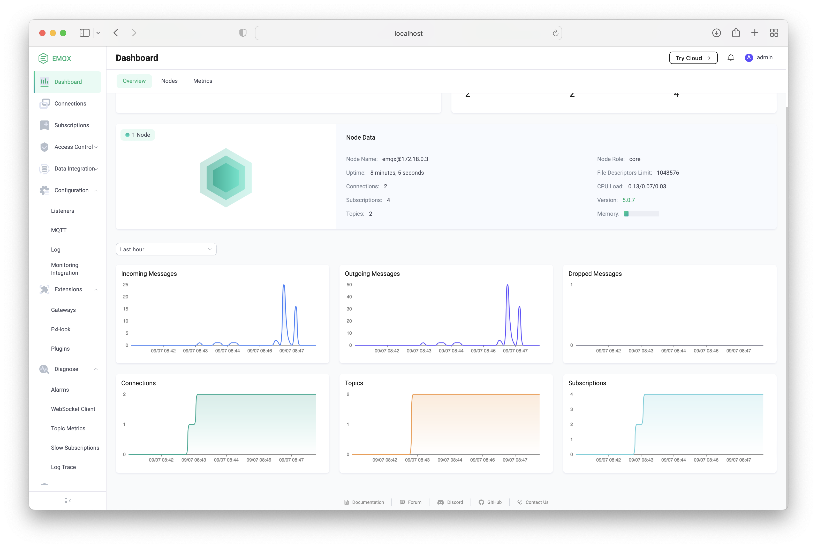

**Dashboard**

